New and Renewal Submission Checklist

Premera Industry Trust submission (groups 5+)
Kaiser Permanente Industry Trust submission (groups 2+)
Kaiser Permanente Small Group submission (groups 1 -50)

New Case Submission Checklist
1st Month Premium Check* - Payable to: BHT
EFT (Electronic Funds Transfer) Authorization Form*
Group Master Application completed via AP Connect
BHT Membership Partner Confirmation
- Proof Accepted: email payment confirmation, invoice, payment statement, or image of payment
- Refer to AP Connect for a list of BHT Partners and links
- Note: Kaiser Small Group receives a complimentary Seattle Chamber Membership
Complete Census Enrollment Spreadsheet or Enrollment Forms
Complete waivers, if applicable
Late Submission Form if submitting after the 15th of the month

*If an EFT form is being provided, it is not necessary to provide the first month premium check. The first month premium can be processed as an EFT if the Effective Date of Authorization on the EFT Form is the same as the group’s original effective date.

Mail Premium Checks to:
Payable to: BHT
PO Box 6
Mukilteo, WA 98275

Renewal Case Submission Checklist:
Group Master Application completed via AP Connect
BHT Membership Partner Renewal Confirmation
Submit by the 15th of the month (Disclosure: If renewal is received late past the 15th, ID cards, etc. could be delayed)

What to expect after New Group Submission:
AP will review and reach out to you to collect anything that is missing. AP is unable to submit business without all required items. Once verified, AP will submit your new group to the underwriter for final rates and approval and then submit to the TPA (Vimly).
Vimly will load the group information into their system and submit a full electronic file to the carrier(s) to load both the group and members into their system.
Medical and dental group numbers will be sent in a separate email from bht@vimly.com to the group and producer listed on the GMA once assigned by the carrier. Producer Support role is not included.

The initial invoice will be issued in a secure email from bht@vimly.com with a request to review for accuracy. Welcome email details from BHT and Vimly are listed below.

BHT Welcome Email will be sent to the group contact with a copy to the producer once AP submits the group to the TPA (Vimly) and includes:
- Link to the BHT Employer Resource Hub
- Checklist for what to do next
- Template Overview attachment that can be tailored to each group and distributed to employees.
- Contact detail with email addresses and phone numbers for various items
- Tutorial videos related to the TPA Vimly’s online platform SIMON (Note, group needs to wait for the SIMON invite in the Vimly Welcome email detailed below)
- First month checklist and additional resources
- Link to BHT site which contains:
  - Plan summaries & booklets
  - Forms library
Vimly (TPA) Welcome Email [sent securely from bht@vimly.com] will also be sent to the group contact, with a copy to the producer. This email confirms the group and members are loaded with the carriers and includes:
- First month’s invoice – Please review for enrollment accuracy
- Instructions for accessing SIMON for eligibility and bill pay options
- BHT Welcome video with information related to BHT and all options available to new groups
- SIMON Resource Page Provides:
  - How Vimly COBRA Administration Works
  - SIMON Authorization form (this document allows you to give SIMON access to other administrators within your company)
  - EFT Authorization form
  - Group Administration Guide
  - Benefit Booklets
  - Credible Coverage Notice (if applicable)

Physical ID Cards:
- Will be sent within 14 days of receipt of the initial BHT Welcome Email for Medical and Dental
- ID #’s cannot be sent to the group or producer
- Cards arrive separately in plain white envelopes
- If elected, VSP does not issue ID cards
We strongly recommend that producers login to AP Connect and download the appropriate plan summaries and booklets for your group(s).
Deductible Credit Process:
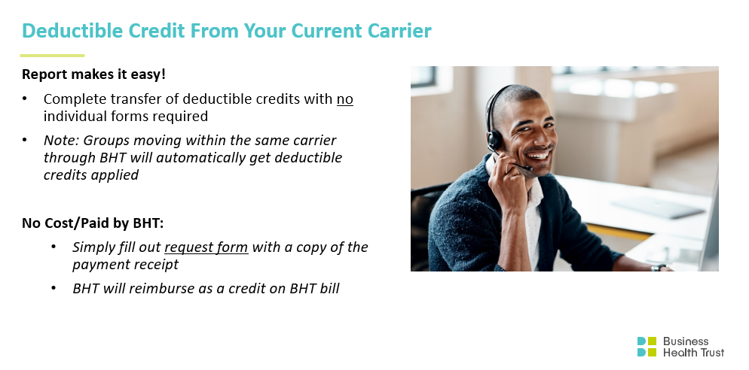

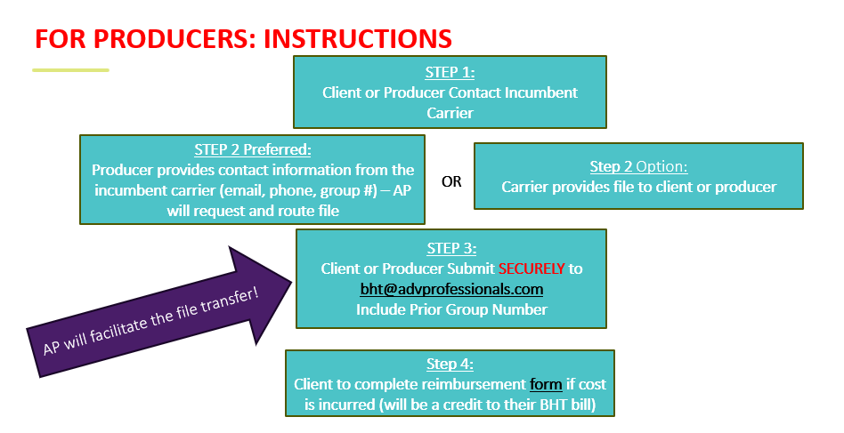

Link to Reimbursement Request - https://www.surveymonkey.com/r/FFKSMTW

